normal code
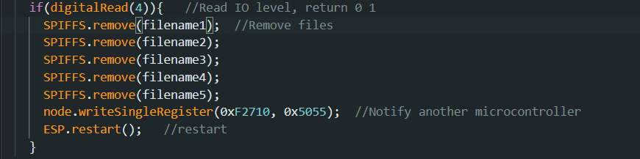

Restart log 115200 baud rate
Program starting point
IO changes detected

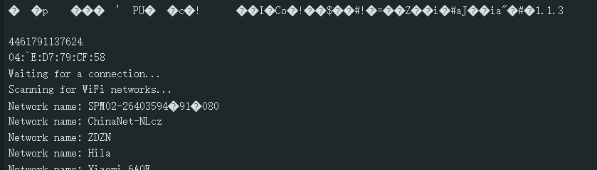

This is a normal process

The problematic code
Only added an if
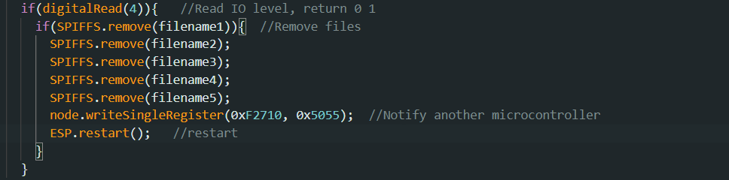

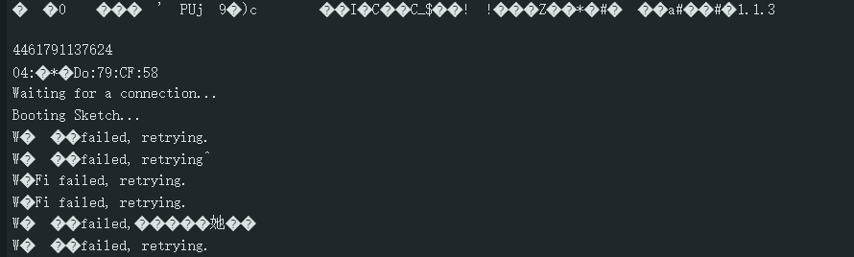
Why?

Why does this error occur after restarting when using "if" to determine whether deletion is successful?

