Device Log Comparison: Working vs. Failed Logs:
This document explains where and why the Application stalls by comparing the working device log with the failed device log.
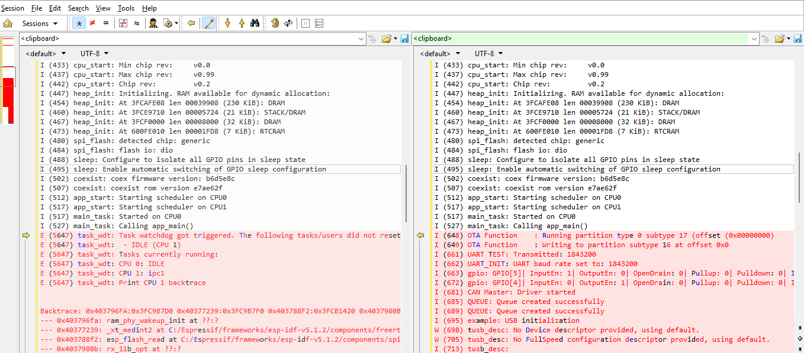
Issue Log
Working Log

Device Failure Root Cause Analysis:
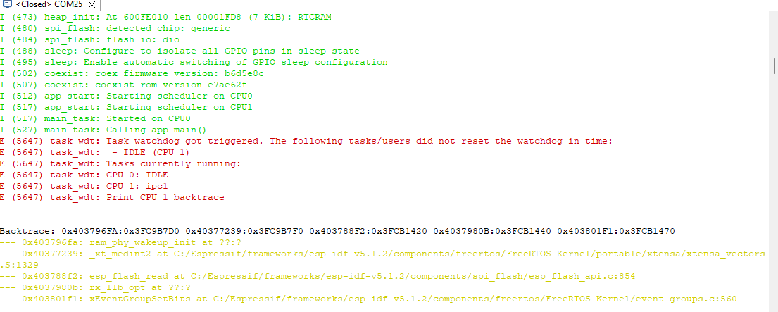

In the failed device log, everything proceeds normally up to app_main(). Both CPUs start, but as soon as the application begins running (inside app_main()), the watchdog timer is triggered because:
- The IDLE task on CPU1 (App CPU) does not reset the watchdog.
- The CPU is essentially stalled, likely during WiFi PHY wake-up combined with flash read operations, causing a deadlock.

